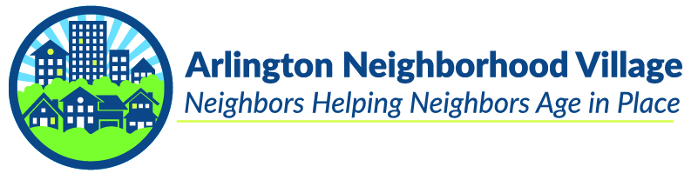

**Light Up Someone’s Life…Volunteer!**

**Volunteers are essential to Arlington Neighborhood Village**

Arlington Neighborhood Village is a non-profit organization dedicated to enabling Arlington County residents aged 55 and older to continue living in their own homes and communities as they age.

Volunteers make our county-wide village work, and we welcome adult volunteers aged 18 and older.  We will work with you to match our members’ needs to your preferences, schedules, and skills – providing transportation, running errands, assisting with light home repairs, technology, and more.  As a volunteer, you’ll receive training to provide services for Arlington Neighborhood Village members.

You can also lend your expertise behind the scenes! ANV needs volunteers to help on all the tasks that make an organization run smoothly—from practical, daily tasks like finance and IT to strategic efforts like fundraising and long-range planning. If you have career experience you’d like to contribute, or an area you’d like to learn more about, we’ll work with you to find a way to apply your skills and interests.

**As an ANV volunteer you’ll not only contribute to the well-being of our members, you’ll enhance your own life through:**

* Effecting positive change in the lives of your neighbors
* Meeting new people and widening your circle of friends and acquaintances
* Developing and strengthening connections to your community
* Increasing your knowledge of your community and its resources
* Learning new skills and developing new interests

**ANV needs volunteers to:**

* Provide transportation for medical appointments, grocery shopping, the bank, post office, and library (transportation is our most requested service!)
* Run errands like picking up prescriptions or food
* Assist with household tasks like changing lightbulbs, putting batteries in smoke detectors, and hanging pictures
* Be a friendly visitor or walking buddy
* Provide technology support such as computer troubleshooting, help with a smartphone, or setting up a new TV
* Help with home organization and occasional yard or gardening work

**How volunteering with ANV works:**

* All volunteers must be 18 or older, 21 if you wish to drive
* The first step is to fill out the Volunteer Application Form at <https://anvarlington.org/volunteer-interest/>
* Then, you must attend a live 45-minute Volunteer Training Session on Zoom
* After the training, you will submit to a background check (and driving record check for volunteer drivers)
* Once approved, you will receive regular emails showing open requests for the types of services you wish to provide
* You choose whichever request or requests work for your schedule at that time. If nothing does, you simply wait for the next email.
* Complete the service and enjoy your time helping an older adult!

We look forward to working with you to accomplish our mission of enabling Arlington seniors to remain in their homes and communities as they age. Questions? Please email us at volunteer@ANVarlington.org, or call us at 703-509-8057.

Want to give back to your community but don’t live in Arlington? Or help an older adult find support in their area? 300 neighborhood villages operate in 45 states and the District of Columbia, helping seniors age in place and live vibrant and independent lives in their own homes and communities. Check out the National Village to Village Network at [www.vtvnetwork.org](http://www.vtvnetwork.org) or the DC area’s directory at [www.wavevillages.org](http://www.wavevillages.org).

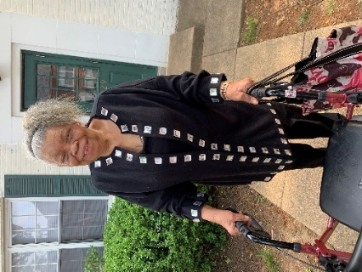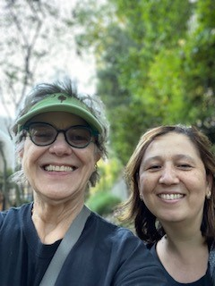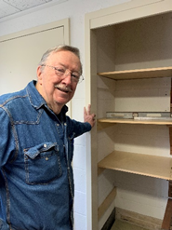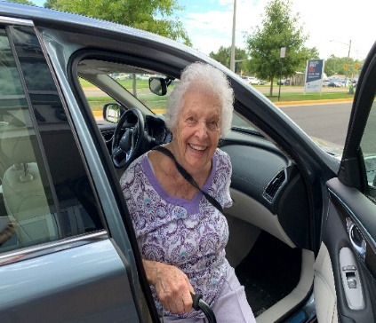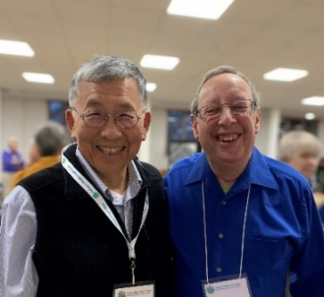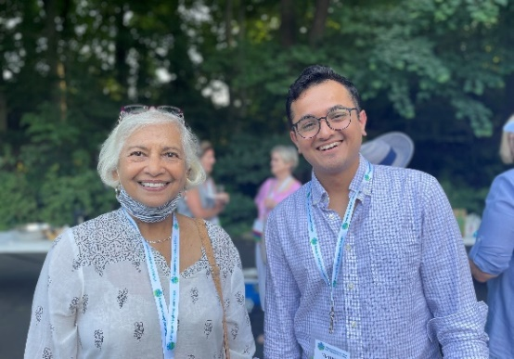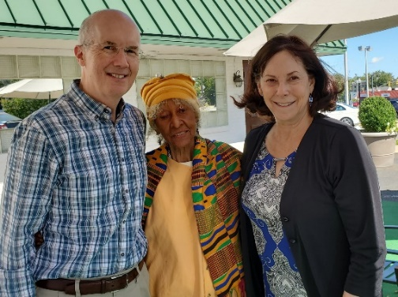

**Arlington Neighborhood Village**

**4000 Lorcom Lane, Arlington, VA 22207**

[**www.ANVarlington.org**](http://www.ANVarlington.org) **703-509-8057**